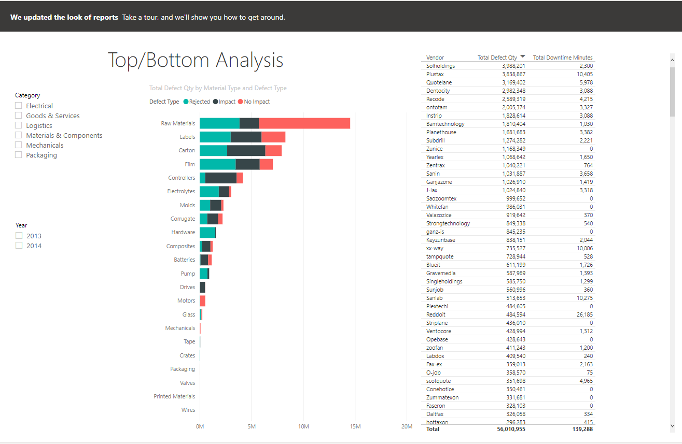

In this dashboard, the dashboard represents a top/bottom analysis of the supplier quality analysis.The bar chart represents which materials’ type and how it is defective. As well, the legend on the left has the type of the materials, where you can check the different types of material that you want to see. If you do not check any of the categories, it will show all of the materials on the bar chart. As well, there is also a year legend, which can show which year when you have the type of defects there were in that year. However, you are only able to check one box per category. This means that you can only check 2015 or 2014 and not both. In the center of the page shows the bar chart. In the chart, it will show how much of the material was considered defective. There are three categories of defective products, which are rejected, no impact, and impact. The number of defective materials is by millions in the bar chart. On the right of the bar chart shows how much each vendor has defective materials in numerical form. There are three columns that represent the vendor, the total amount of defective materials, and the amount of downtime that the defective materials have caused.